**Campus Media**

List of functional features:

1. Automatic time table generation - Administrator can design time table
2. Normal users (Student, Teacher etc.) can view the Time table
3. Notice Board with one way communication i.e. administration office notifications to faculty and students, club notifications, faculty notifications to the class.
4. Notification can be used to convey Information about the assignments, project deadlines etc. to individuals.
5. Social media platform for a college where formal and informal communication can take place.
6. Facility to create the Study groups, Clubs and Class groups etc.
7. Feedbacks regarding the events, teachers etc.
8. Online score cards for different subjects and quiz reports with notifications

Type of users:

1. Regular Students
2. Correspondent students
3. Alumni
4. Regular faculty
5. Visiting faculty
6. Admin
7. Director
8. Management
9. Staff

Type of defined users in application:

1. Admin
2. Faculty
3. Students

College Benefits:

1. Smooth flow of information
2. Easy to manage teacher schedules
3. Class Feedbacks
4. Easy to manage/update class schedules
5. Notifications to students, faculty,
6. Meeting notifications to students, faculty
7. Local social media network

**Designs:**

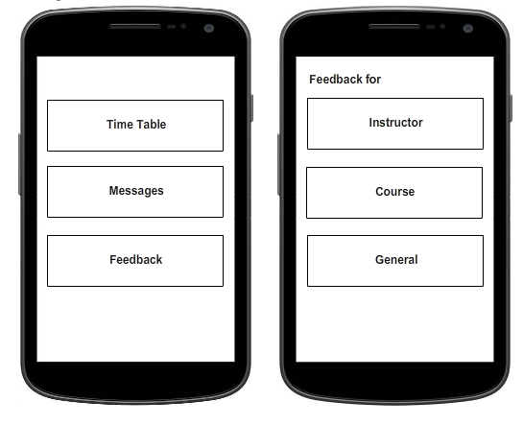

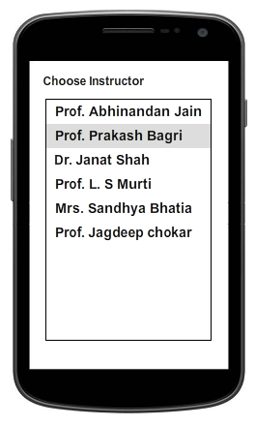 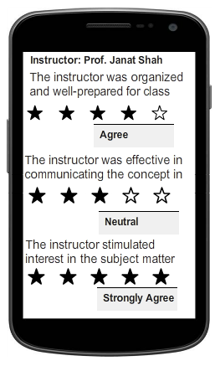

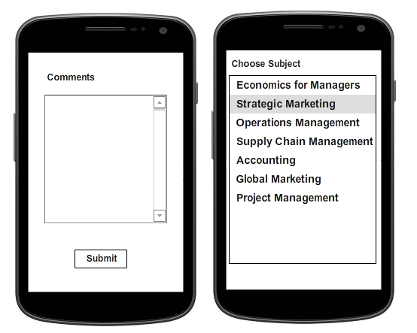

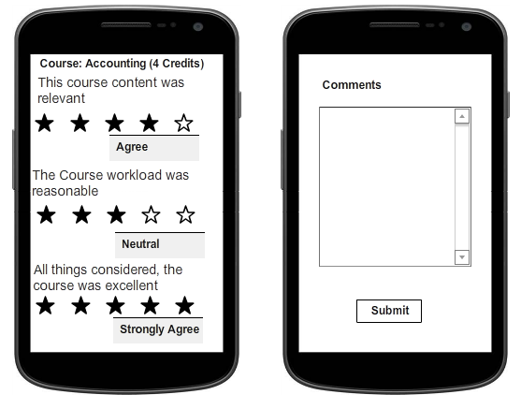 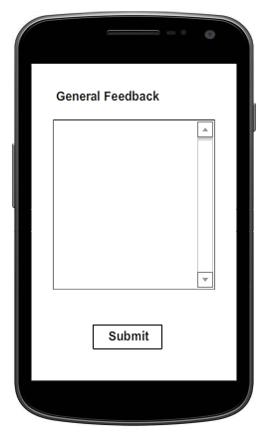

**Designs for admin panel:**

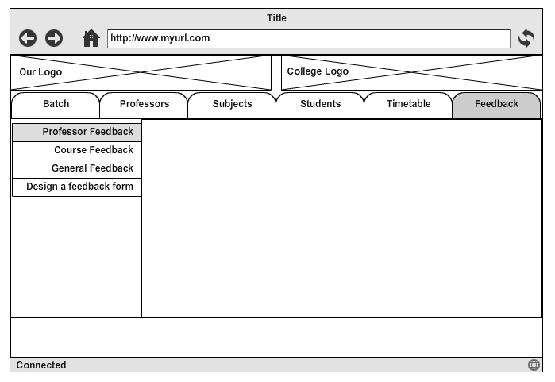

A general layout for feedback tab.

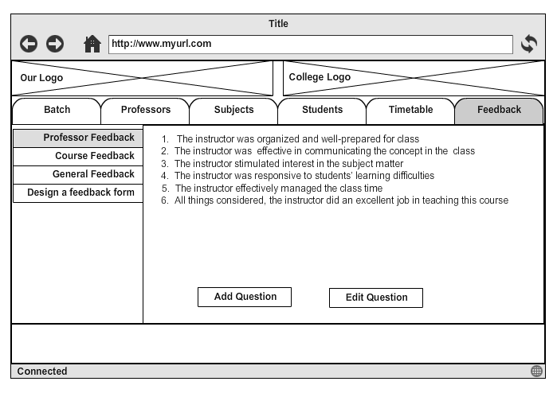

Design for professor feedback tab containing sample questions.

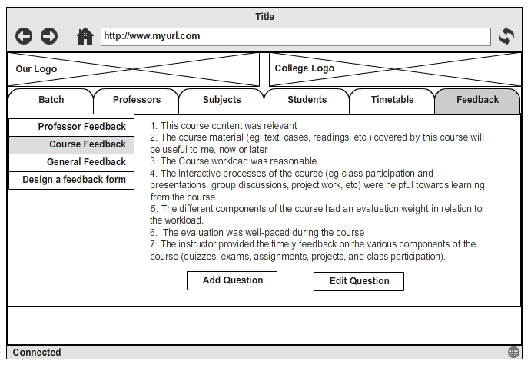

A design containing course feedback tab. This tab will contain sample questions for course feedback.

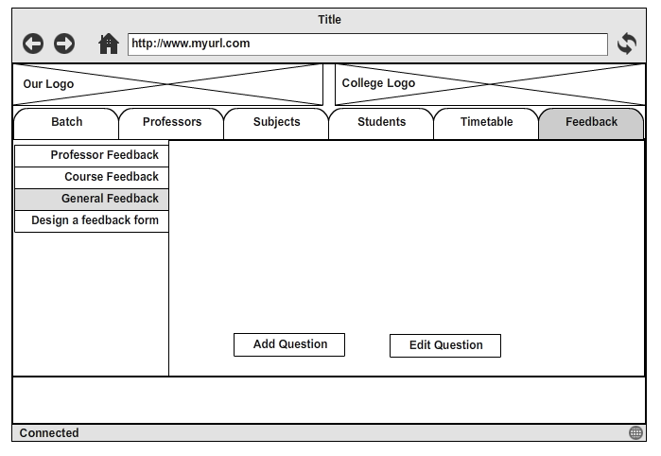

A design for general feedback tab which gives liberty to the admin to add questions according to his/her need.

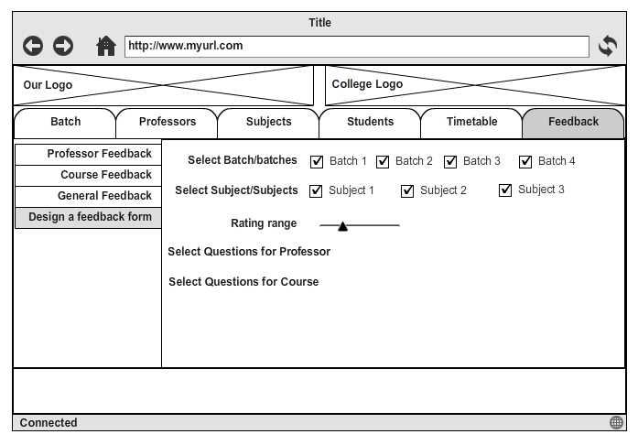

Design a feedback form provides tools to admin to design a feedback form according to his/her needs.